In interior design, drawing techniques are essential for communicating ideas, visualising spaces, and planning layouts. These techniques help designers convey their concepts clearly to clients, contractors, and other stakeholders. What follows here is a short guide that explains a range of different techniques used by interior designers. It includes examples of student work to aid your understanding of the other techniques you will learn throughout your course.

**Note:** These examples are for your reference only. They should not be copied or assumed to be one hundred percent accurate.

## Sketching

A sketch is a quickly executed freehand drawing. It is usually completed using a pencil or pen. Graphics are used to explore and develop a design idea. Annotations can be added to explain the design idea being illustrated.

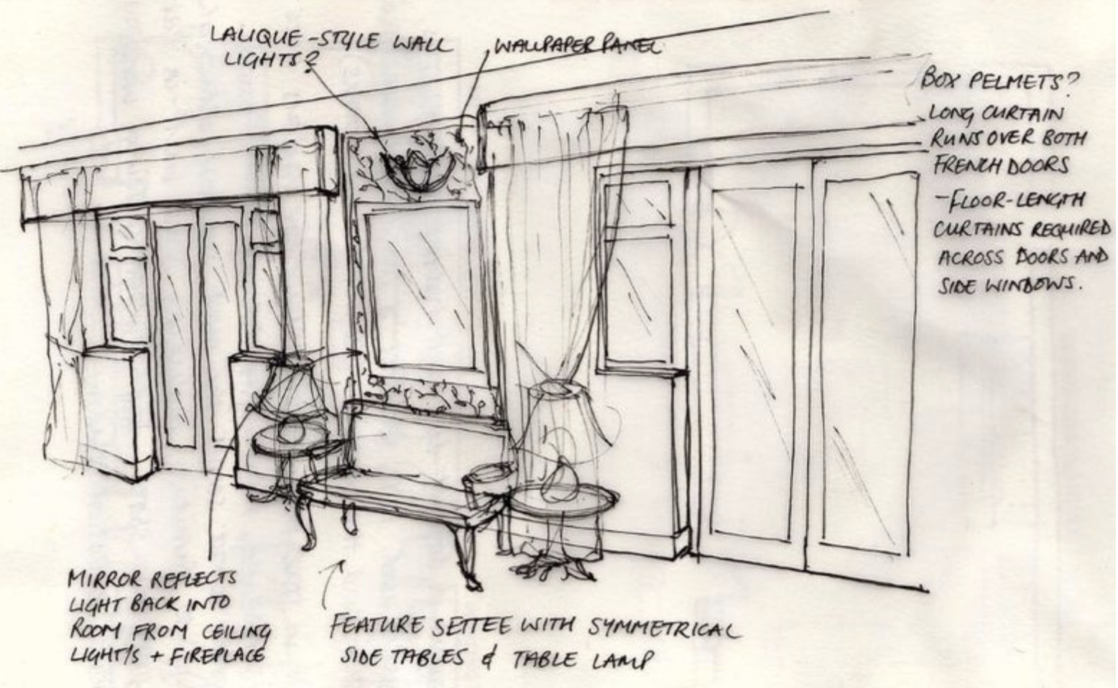

Fig 1. Example of a sketch with annotations

**Sketches** can be categorised depending on their purpose. Initial draft sketches may include drawings of preliminary ideas for possible solutions to the brief**.**

**Freehand sketches** are quick, informal drawings that allow designers to capture ideas, explore concepts, and communicate initial thoughts. Freehand sketches are often the first step in the design process and are used to develop more detailed drawings.

**Concept sketches,** on the other hand,are used to visualise and explore different design ideas, layouts, and arrangements before committing to a final plan. These sketches are typically more refined than initial freehand sketches.

## Rendered perspective drawing

This technique is used to communicate an idea by creating a realistic impression of the design. A design can also be shown as a 3D space which showcases the colour, material finishes, etc. Rendered perspective drawings can help the client gain a much clearer understanding of the design.

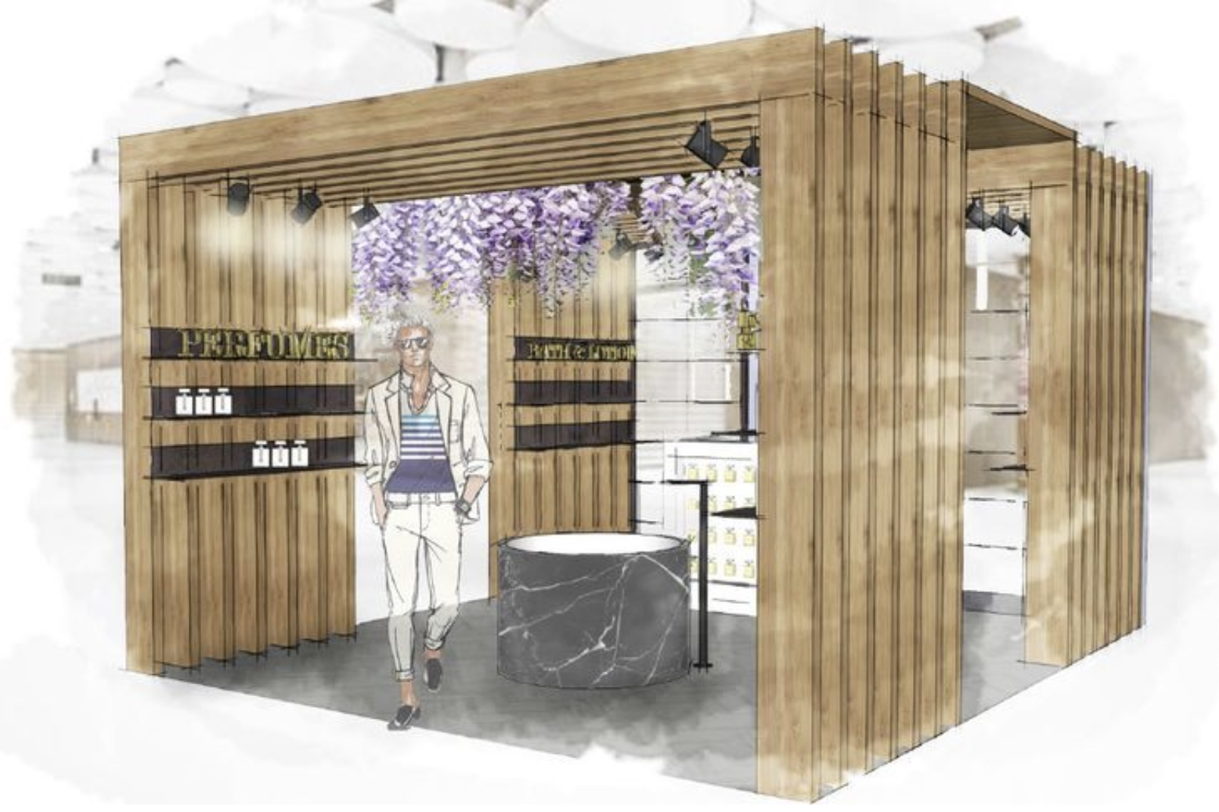

Fig 2. Example of a rendered perspective drawing

## Floor plans

A technical floor plan is a 2D drawing completed to scale. It is a view from above, looking down on the room or a floor in a building. It is created by having an imaginary horizontal line that cuts the room or building approximately 1200mm above the floor. The drawing can be used as a base to show elements such as furniture layout, electrical fixtures etc. .

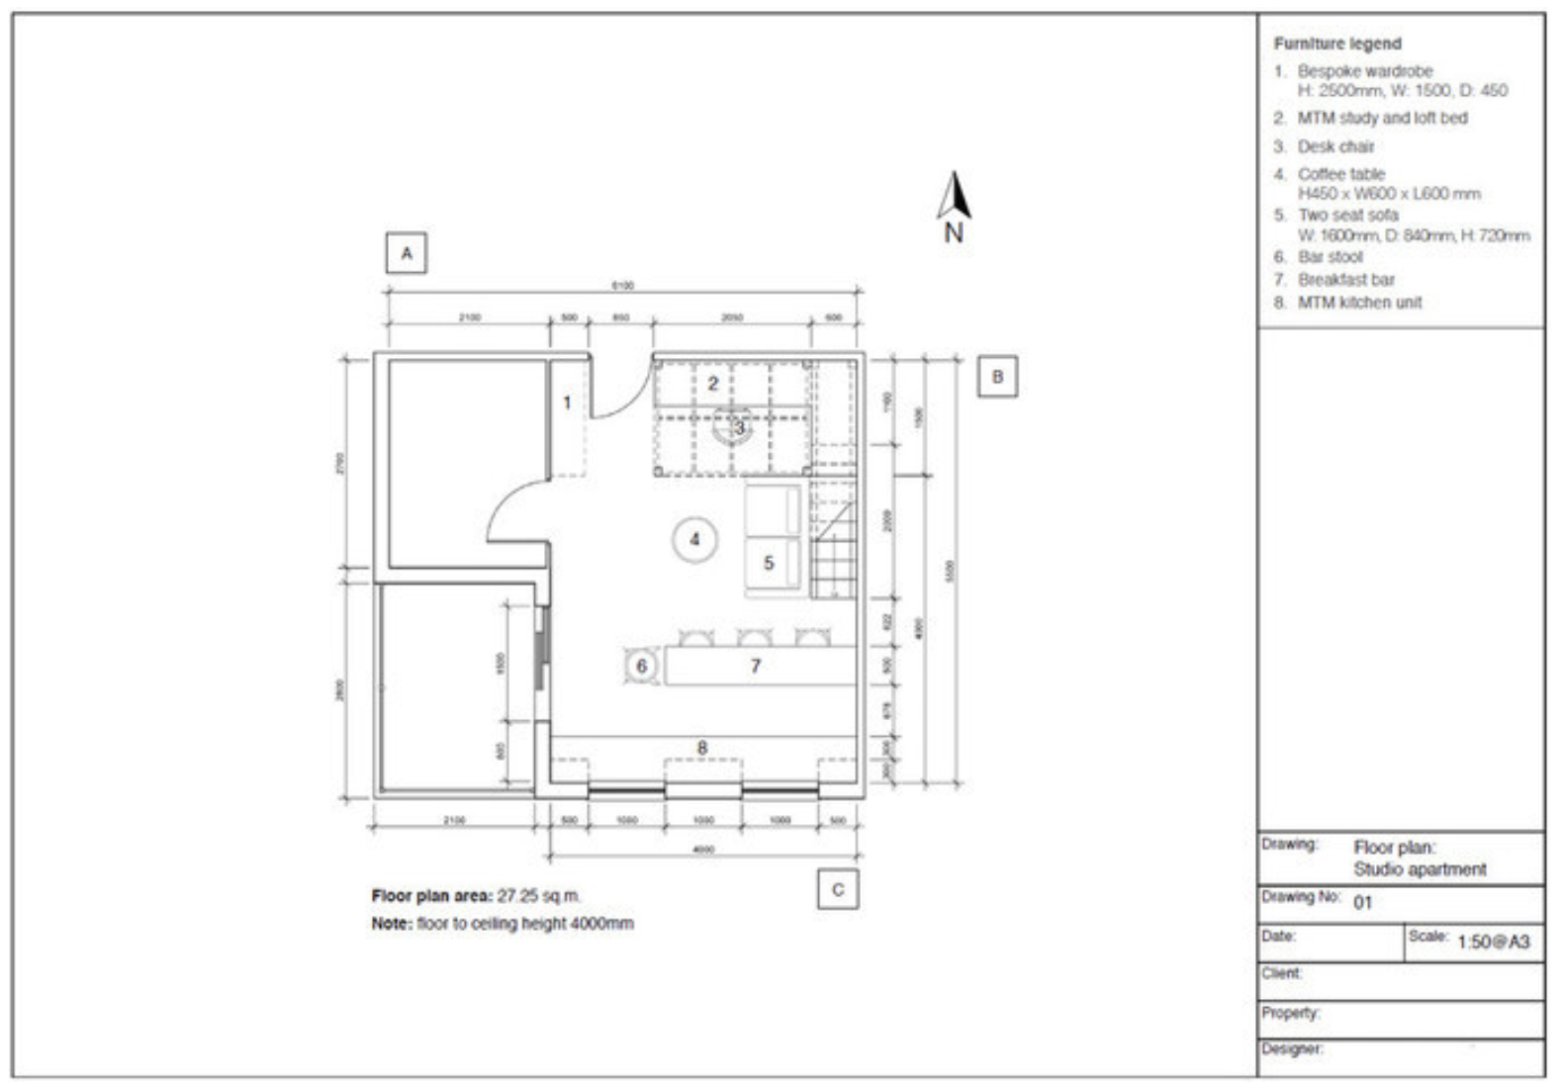

Fig 3. Example of a floorplan

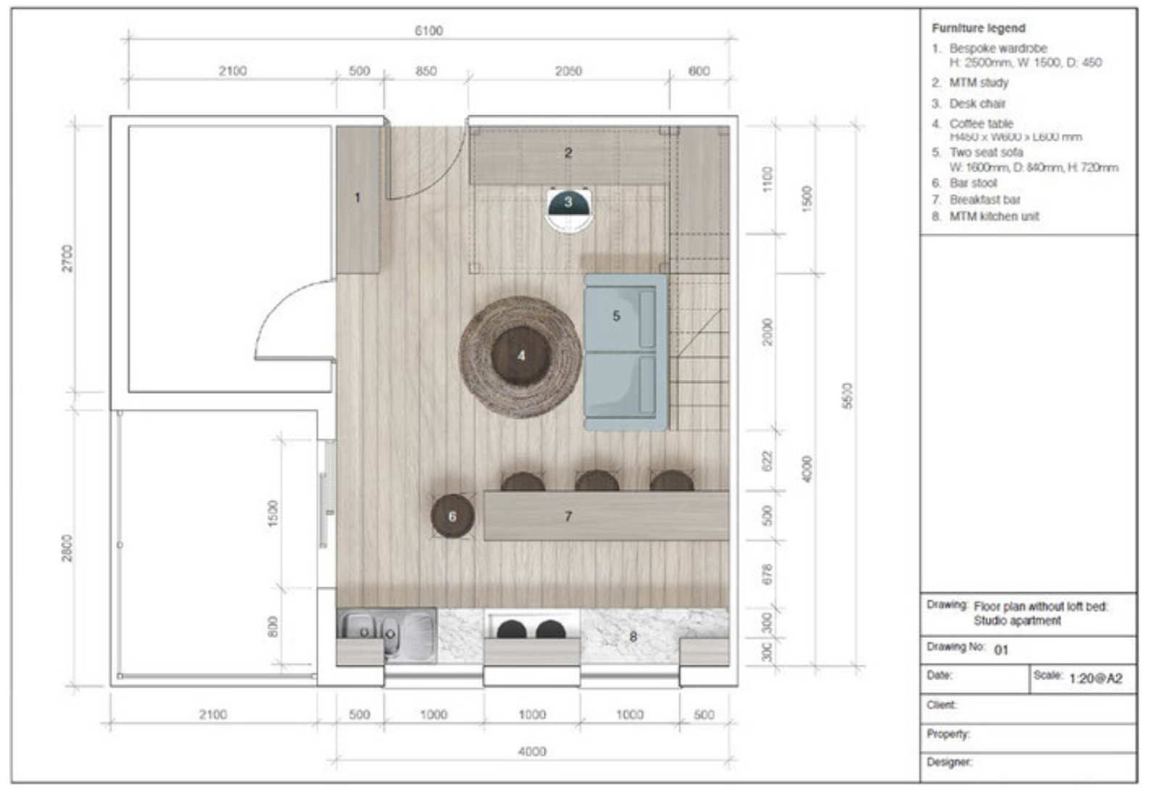

Fig 4. Example of a colour rendered floorplan

## Elevations

A technical drawing of an elevation is a 2D drawing completed to scale.

**Interior elevations** are scaled 2D drawings that illustrate the width and height of an interior wall of a room. These types of drawing, in interior design, are mostly used to depict specific parts of the design concept, such as a built-in shelving unit or a feature wall. In kitchen design, elevations of all walls are required, to show the height of kitchen units, as well as any overhead storage, such as shelving or cupboards etc.

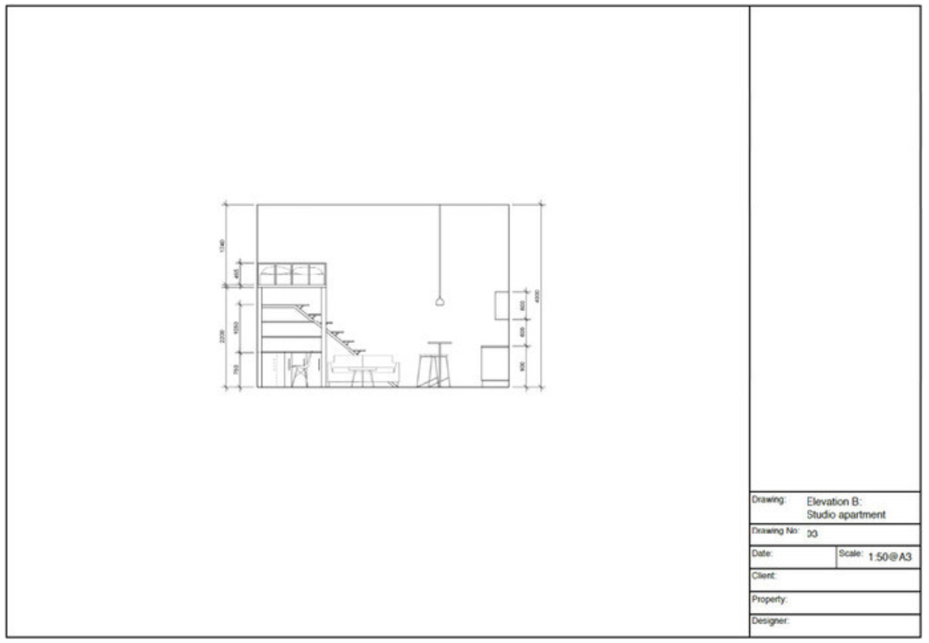

Fig 5. Example of an interior elevation drawing

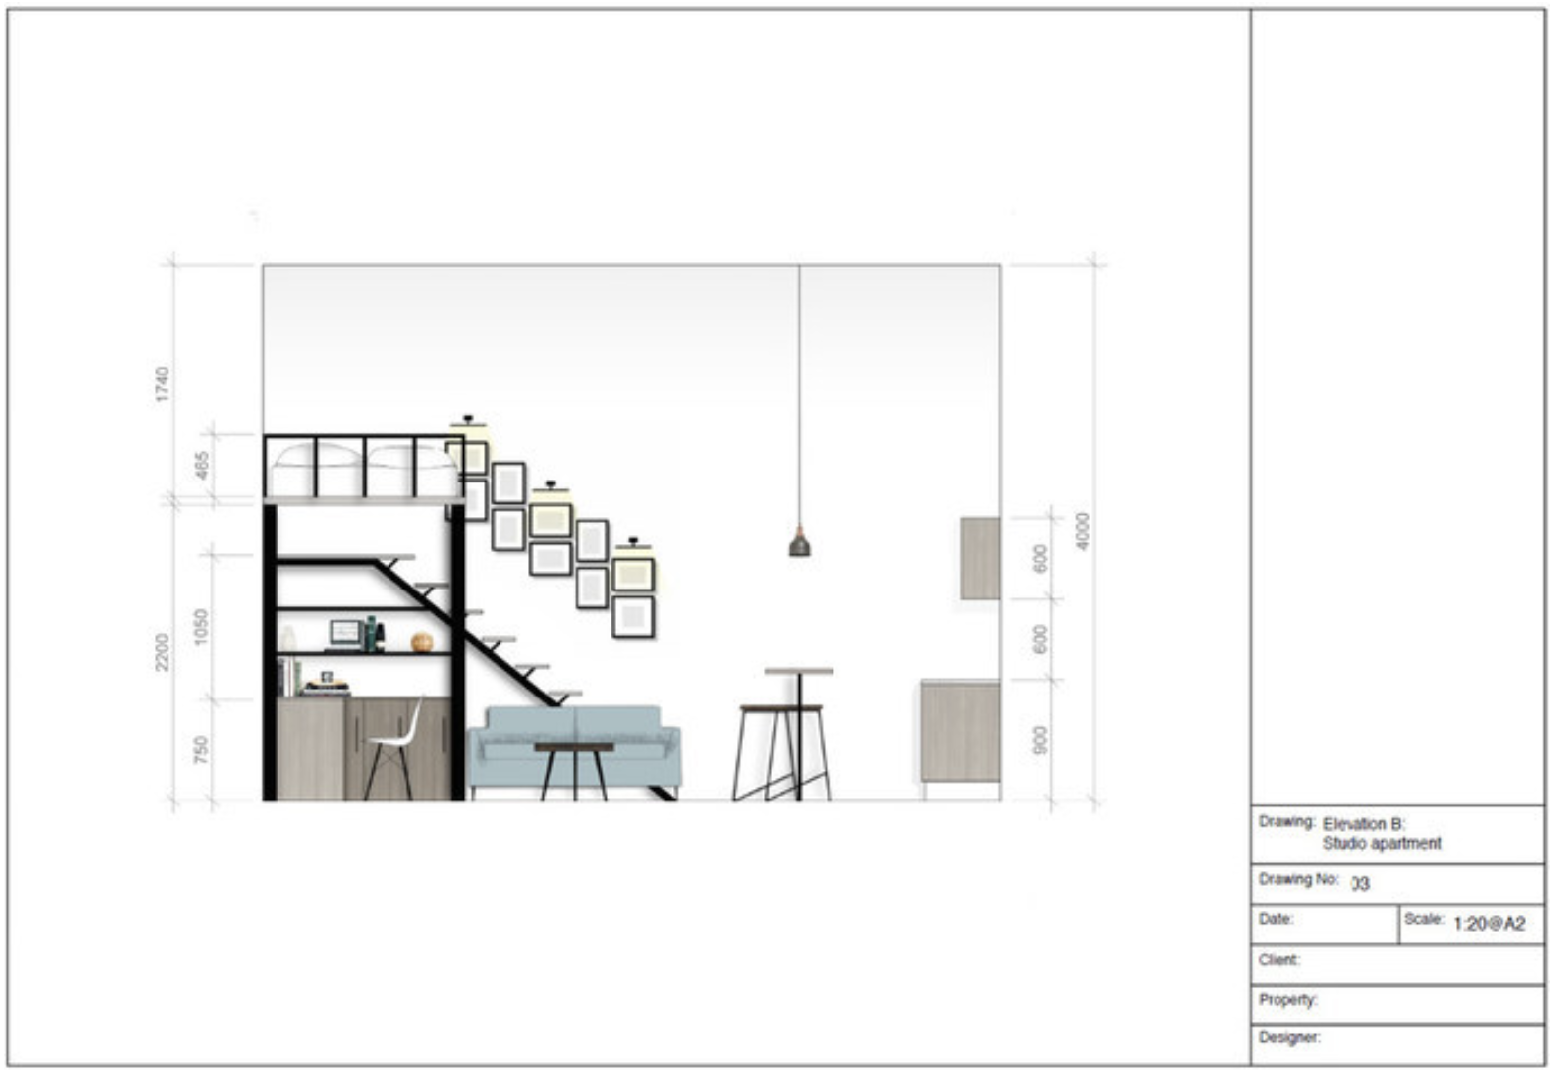

Fig 6. Example of a colour rendered interior elevation drawing

**Exterior elevations,** otherwise known as facades, and more common in architecture, are drawings that depict the façade of the building. They can be relevant in interior design when dealing with large-scale renovations or designing spaces that impact the exterior façade, such as patios or outdoor living areas.

## Perspective Drawings

Perspective drawings move away from the concept of 2D drawing and incorporate a third dimension, making them 3D. Perspective drawings display a more immersive point of view of a room. Perspective drawings can be a one-point, two-point or three-point perspective drawing, depending on the amount of vanishing points the designer chooses to implement.

#### One-Point Perspective

This type of drawing uses a single vanishing point on the horizon line, where all lines parallel to the viewer's line of sight come together. It is useful for drawing rooms viewed from the front, with walls and furniture aligned along the vertical and horizontal axes, such as a hallway or room looking towards one wall. This technique adds depth and helps visualise how furniture and elements are arranged.

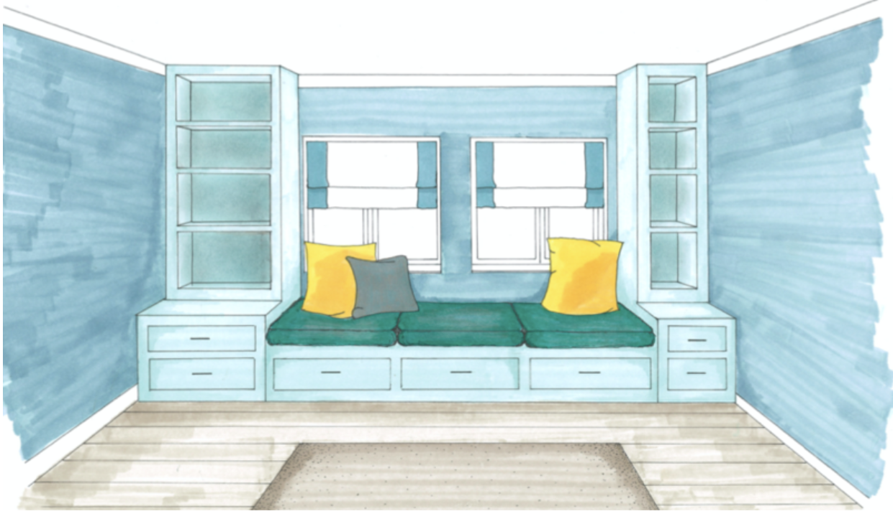

Fig 7. Example of a render one-point perspective drawing

#### Two-Point Perspective

In a two-point perspective drawing, there are two vanishing points on the horizon line. The lines that define the width and depth of objects, converge toward these two points. This technique offers a more dynamic and realistic view of an interior space and is commonly used when drawing rooms or furniture from a corner, giving a sense of depth and space. It's often used to depict living rooms, bedrooms, or larger open-plan spaces.

**~~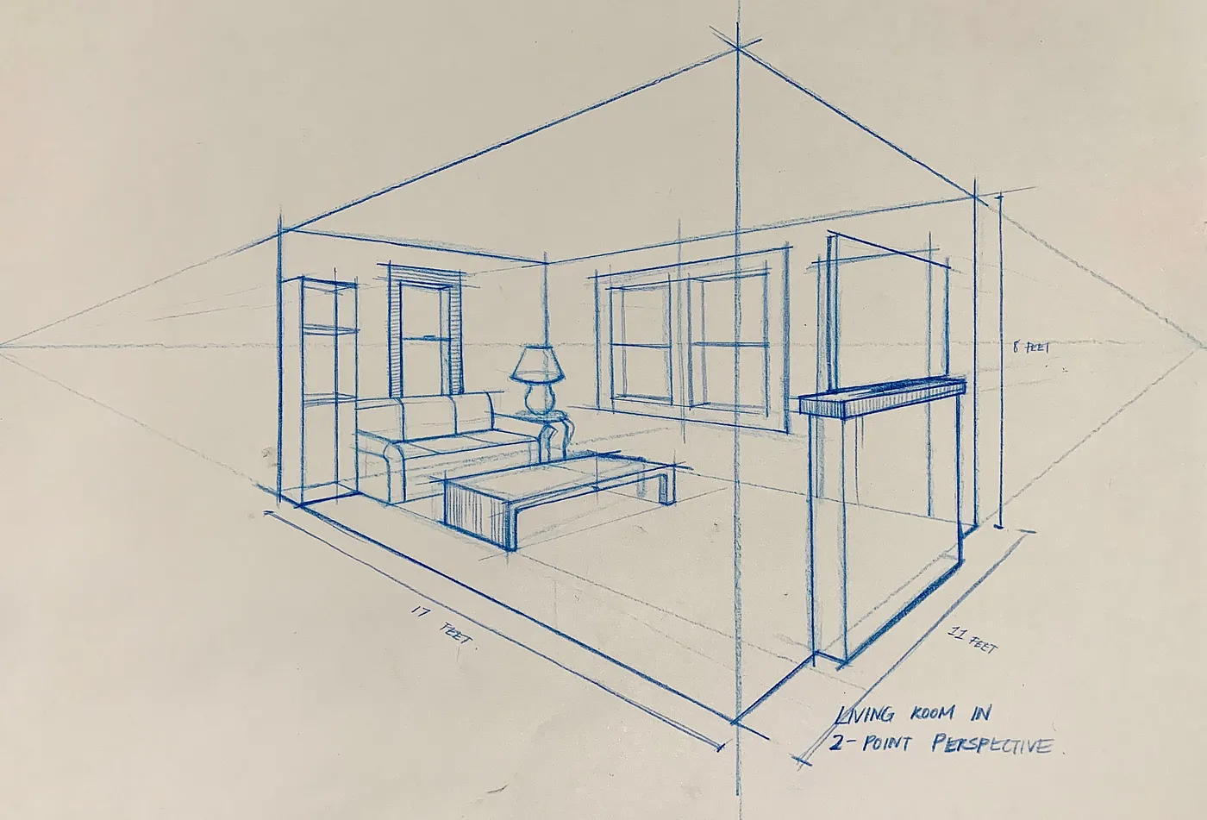~~**

Fig 8. [Maggie Ma](https://maggiemadesign.medium.com/?source=post_page---byline--6d4b573045e8--------------------------------) (2020) [Example of a render two-point perspective](https://maggiemadesign.medium.com/perspective-systems-6d4b573045e8) [drawing]

#### Three-Point Perspective

This technique adds a third vanishing point either above or below the horizon line, allowing for a sense of height. It’s often used when illustrating high-ceiling rooms, lofts, staircases, or dramatic views from above or below. It is also useful for emphasising the vertical aspect of a space, like foyers or multi-story interiors.

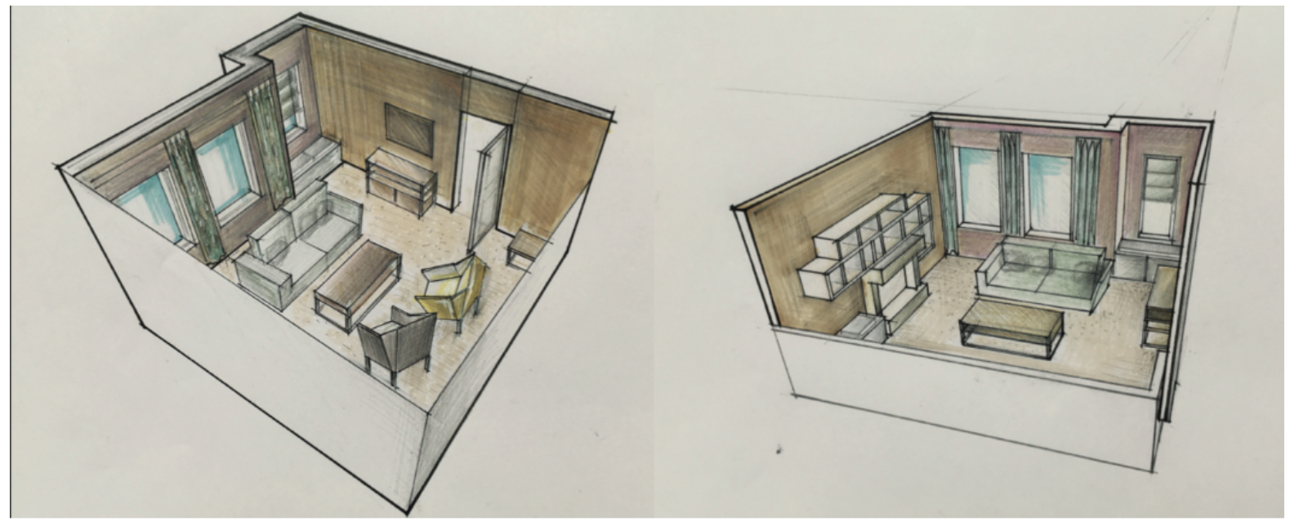

Fig 9. Example of three-point perspective drawing

## 6. Axonometric and Isometric Drawings

**Axonometric drawings** are a form of 3D drawing where the design is shown from an elevated corner angle (i.e. an eagle eye view point), with all dimensions scaled equally. **Isometric** drawings are useful for visualising entire interiors in three dimensions in order to understand the relationship between most elements of the room.

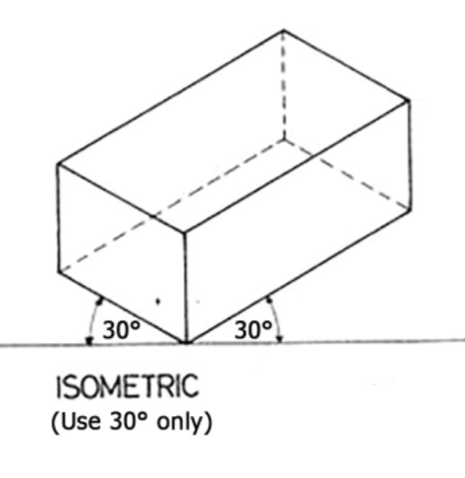

Fig. 10 Isometric Drawing

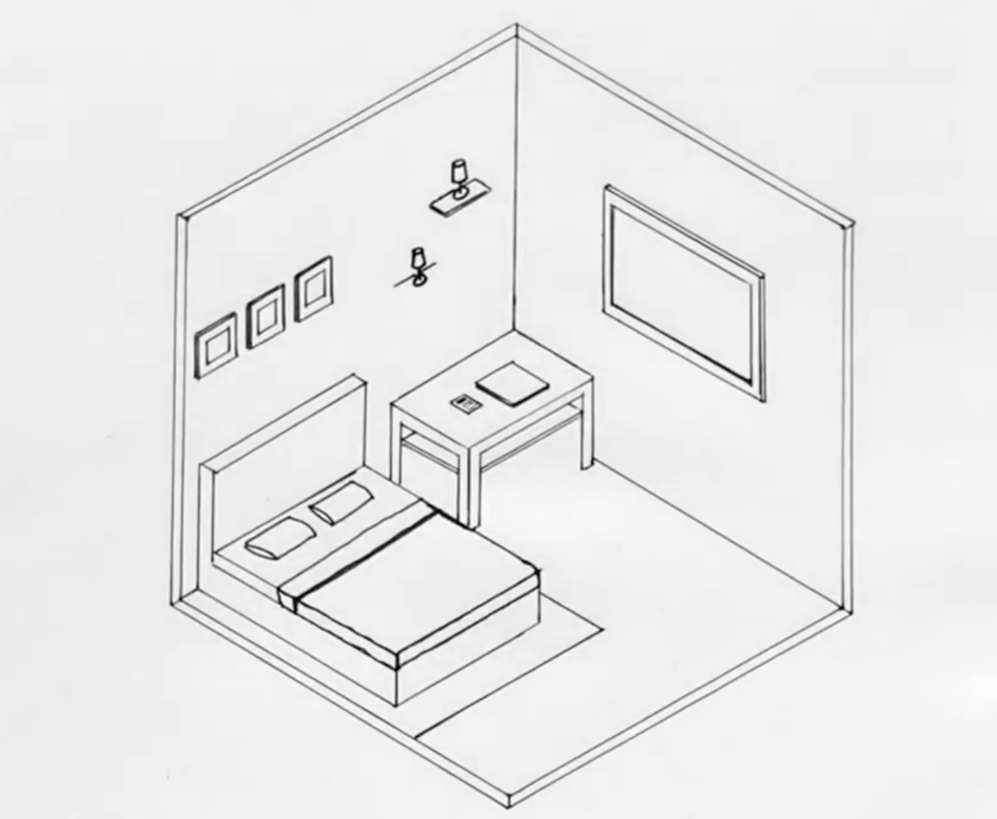

Fig 11. The Art Academy (2021) Example of an isometric drawing

**Isometric** drawings are a particular type of Axonometric drawings, where we use the same scale and angle on all axes to draw a space. We also have dimetric and trimetric, which use different scales, accordingly.

## 7. Section drawings

**Cross-sections** are vertical cuts through a building, room, or product, that show the relationship between different levels, spaces, and structural elements. Sections provide insight into the height, depth, and construction of a space, often highlighting the relationship between floors, ceilings, and walls, or details such as drawers and shelves, in the case of furniture design.

**Detail sections** focus on specific areas or elements within a space, providing more detailed information about construction, materials, and connections.

To conclude, the ability to develop and make use of drawing skills is something which assists throughout the process of developing an Interior Design project. Generally speaking, all these techniques are learnt, and contrary to fine art and painting, there is no real need for “talent” in order to apply and utilise all of the above types of drawing within your journey of developing a Design Proposal for your client. Having said that, these techniques can be used as and when you, as the designer, deem them necessary, in order to serve the purpose and communicate your ideas clearly.

**References:**

The Art Academy. (2021, August 19). *How to draw an isometric room* [Video]. YouTube. https://www.youtube.com/watch?v=4nUFzdiLCfE